Dionysos Programming Guide
Creating Dionysos client applications

Table of Contents
Document Information 3
History 3
ABSTRACT 4
1 Introduction 5
2 Client architecture overview 5
2.1 ChronosLib 5
2.1.1 Package control 6
2.1.2 Package model 6
2.1.3 Package persistency 7
2.1.4 Package ui 8
3 Creating the domain model 8
3.1 Modeling in CWM 8
3.2 Generating the code 8
4 Using the client framework to create an application 8
4.1 Directory structure 8
4.2 Main application classes 9
4.3 Configuration 11
4.4 Client-Server communication 12
4.4.1 Simple actions 13
4.4.2 Action sets 13
4.4.3 Persistence operations on domain objects 14
4.4.3.1 Create 14
4.4.3.2 Read 15
4.4.3.3 Update 15
4.4.3.4 Delete 16
4.4.4 Custom actions 16
4.4.4.1 Client-side 16
4.4.4.2 Server-side 18
4.4.5 Long running processes 19
4.4.5.1 Server-side 20
4.4.5.2 Client-side 22
4.4.5.3 Document download 23
4.5 Internationalization 24
4.6 Logging 25
4.6.1 Client-side 25
4.6.2 Server-side 26

Document Information
Author: | Ingo Herwig
Version: | 0.901
Created: | 01/24/11
Source: | The current version of this document can be found under:  http://olympos.svn.sourceforge.net/viewvc/olympos/trunk/olympos/dionysos/docs/Dionysos Programming Guide.odt

History
date | author | changes
01/24/11 | Ingo Herwig | created

ABSTRACT
This document explains how to create Dionysos client applications.

Introduction
The Olympos project includes a specification for client server communication called Dionysos specification. It defines messages that clients and servers exchange in order to accomplish various tasks like logging into the application and retrieving or storing objects. The specification can be found under http://olympos.svn.sourceforge.net/viewvc/olympos/trunk/olympos/dionysos/docs/Dionysos%20Specification%20JSON.odt.
To help developers in creating applications that use this protocol, the Olympos project provides implementations for different platforms. Besides adapters for the Grails (Java) and wCMF (PHP) server platforms, client applications may use the JavaScript adapter, which is part of the ChronosLib package. This programming guide describes how to build browser based applications, that use this library to connect to one of the server frameworks.

Client architecture overview
A Dionysos client application is typically divided into three layers:
- UI Layer: The user interface layer includes all components that the user is directly interacting with, like forms, controls, pop-up windows etc. It is recommended to implement it using a JavaScript framework like ExtJS or Dojo. ChronosLib is built on ExtJs and provides a foundation to easily build the GUI as well as a set of standard controls.
- Model Layer: The model layer consists of all classes representing the domain model and classes helping to manage instances of these. The domain classes are typically generated from a model defined in Chronos Web Modeler. ChronosLib contains the required base classes for connecting the domain model to the persistence layer.
- Persistence Layer: The persistence layer is used to interact with the server application. Standard actions like creating, reading, updating and deleting model objects are implemented already, but users can easily add additional functionality provided by the server application.
Apart from this ChronosLib also provides support for I18N and logging.

ChronosLib
The JavaScript code is divided into packages that correspond to the directory structure found in ChronosLib. The root package is named chi. It contains the following sub-packages:
- editor
- control
- model
- persistency
- ui

Package control
The control/editor package contains input controls. They extend the ExtJs control classes by some features like tool-tips.

Package model
The model package contains all classes for implementing domain models. Figure 1 shows the main classes of this package together with their relations.
A domain model consists of domain classes that are organized in packages. For an application, that provides generic access to the domain model instances (e.g. Chronos Web Editor) it is required to also have descriptions of all domain classes. The so called Metamodel is implemented in ChronosLib as subclasses of ModelElement:
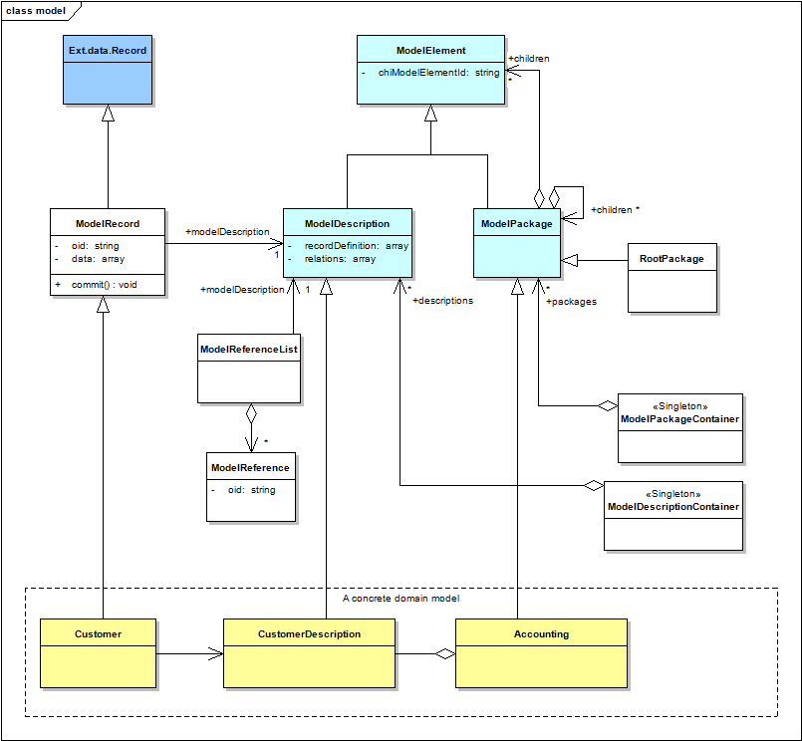Figure 1: Model package overview
- ModelDescription serves as base class for all domain class descriptions. It contains a definition of the domain class attributes as well as the relations to other domain classes. There exists one subclass for each domain class (e.g. CustomerDescription). For each class exactly one instance is registered at the ModelDescriptionContainer.
- ModelPackage is the base class for domain class packages. Each package is represented by one subclass (e.g. Accounting). For each class exactly one instance is registered at the ModelPackageContainer.
ModelPackage and ModelDescription instances may be retrieved from the ModelPackageContainer and the ModelDescriptionContainer singletons. They are identified by the chiModelElementId property, that is inherited from the base class.
Domain classes are subclasses of ModelRecord (e.g. Customer). ModelRecord inherits from Ext.data.Record which is part of the ExtJs library. See chapter 4.4 for examples on how to use domain class instances.
ModelReference and ModelReferenceList are used to handle references to other domain classes. Each ModelReferenceList instance only holds references of one type.

Package persistency
The persistency package contains the classes to establish Client-Server communication. Figure 2 illustrates the package content. Dionysos clients use the interface provided by the Persistency class to make calls to the server application. Currently it contains methods to send all requests defined in the Base, Search and Relation package of the Dionysos specification. All these methods allow to pass success- and errorhander callbacks to process the asynchronous result.
ChronosLib contains two implementations of the Persistency interface:
- DionysosJson is used to communicate to servers that understand the Dionysos protocol directly.
- WcmfJson is used as an adapter to the default wCMF backend application. It basically maps the Dionysos requests to wCMF requests and the wCMF responses back to Dionysos responses.
The actual implementation is defined by setting the configuration value persistencyClass (see chapter 4.3).
To support additional application specific server requests it might be necessary to create a subclass of one of these two classes e.g. CustomJson in figure 2 (see chapter 4.4.4).
The classes ActionSet and LongTask are described in detail in the chapters 4.4.2 and 4.4.5 respectively.
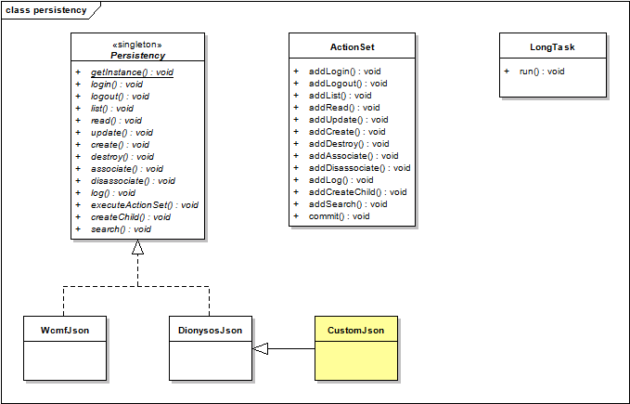Figure 2: Persistency package overview

Package ui
The ui package contains user interface components that may be reused, when creating an application. Currently it contains an ImageSlideshow class and a LongTaskRunner class, that is used to initiate a long running server process and give visual feedback about the progress (see chapter 4.4.5).

Creating the domain model

Modeling in CWM
The Javascript code generator currently only supports the generation of domain classes. For this reason we only take a look at the domain model here. The preferred tool for modeling is the Chronos Web Modeler (CWM). The tool uses the Chronos UML Profile, that applies the ChiNode Stereotype on domain classes and the ChiValue stereotype on domain class attributes. Figure 3 shows a domain model example created with CWM.
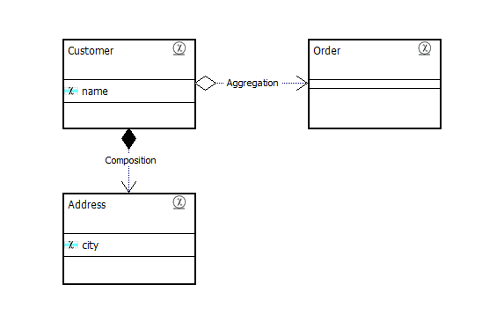Figure 3: Domain model example
Please refer to the CWM documentation for more information about the modeling process and instructions how to use the tool.

Generating the code
TBD Export model, run generator, generated artifacts

Using the client framework to create an application

Directory structure
Applications created with ChronosLib typically use the following directory structure:
- myApp
- css
- img
- js
- application
- domainPackage1
- domainPackage2
- myApp
- model
- persistency
- ui
Workbench.class.js
Config.js
Constants.js
Dict.js
MyApp.class.js
favicon.ico
index.html
- ChronosLib
The example assumes that the application's name is MyApp. It resides in a directory on the same level as ChronosLib. The directories css and img contain the cascading style sheets and images respectively, while all javascript code is put into the js directory. This directory contains subdirectories for the generated domain model (application) and all application specific code (myApp). The latter directory usually has subdirectories for model-, persistency- and ui related code.

Main application classes
The application is started by calling the url of index.html in a web browser. This file imports all javascript code and instantiates the application using the following code:
<!-- PROTECTED REGION ID(index.html/StartApplication) ENABLED START -->
<script type="text/javascript">
Ext.onReady(function(){
Ext.BLANK_IMAGE_URL = "img/s.gif";
Ext.QuickTips.init();
myApp.MyApp.getInstance().startApplication();
});
</script>
<!-- PROTECTED REGION END -->
Note that the code must be embedded into a protected region comment (see chapter 3.2).
The application's main class is myApp.MyApp which is defined in js/myApp/MyApp.class.js. It inherits from the ChronosLib class chi.Main and a minimal version could look like this:
Ext.namespace("myApp");

/**
* @class The main class of the application.
*
* @constructor
* @extends chi.Main
*/
myApp.MyApp = function() {
myApp.MyApp.superclass.constructor.call(this);

this.isInstallErrorHandler = false;
};

Ext.extend(myApp.MyApp, chi.Main);

/**
* Returns the config object.
*
* @return {Object} The config object.
*/
myApp.MyApp.prototype.getConfig = function() {
return myApp.Config;
};

/**
* Starts the workbench.
*/
myApp.MyApp.prototype.startWorkbench = function() {
this.viewport = new myApp.ui.Workbench();
};

/**
* Returns the instance of the application class.
*
* @return {myApp.MyApp} The instance of the application class.
*/
myApp.MyApp.getInstance = function() {
if (!myApp.MyApp.instance) {
myApp.MyApp.instance = new myApp.MyApp();
}

return myApp.MyApp.instance;
};
This class is a singleton and it's main purpose is too provide the application specific configuration via the method getConfig (see chapter 4.3 for details) and starts the application specific user interface via a call to startWorkbench. The base class presents the log-in dialog, starts the session and workbench on success. It will also install error handlers, that help debugging application errors, when the property isInstallErrorHandler is set to true.
The application's user interface is defined in a class, that is usually called Workbench and resides in the myApp.ui package. This class extends Ext.Viewport, that fills the browser's viewport. A minimal implementation would look like the following:
Ext.namespace("myApp.ui");

/**
* @class The main Workbench (perspective).
*
* @constructor
* @extends Ext.Viewport
* @param {Object}
* config The configuration object.
*/
myApp.ui.Workbench = function(config) {
myApp.ui.Workbench.superclass.constructor.call(this, Ext.apply(this, {
layout : "border",
items : [
// add ExtJs ui components here
]
}, config));
};

Ext.extend(myApp.ui.Workbench, Ext.Viewport);
The purpose of the code in the remaining files Config.js, Constants.js and Dict.js is described in chapters 4.3 and 4.5 respectively.

Configuration
The application configuration is stored in the file Config.js in the application directory (see chapter 4.1). It is basically an object that is passed to the processConfig method of the chi.Config singleton, where each property defines a configuration value. The chi.Config class defines default values for common properties, which may be overwritten by the application specific configuration. The following code shows an example configuration with explanations for the configuration values.
Ext.namespace("myApp.Config");
/**
* The URL all JSON calls should be routed to.
*
* @type String
*/
myApp.Config.jsonUrl = "../application_wmm/main.php";
/**
* The Persistency implementation.
*
* @type String
*/
myApp.Config.persistencyClass = "chi.persistency.DionysosJson";
/**
* Timeout of AJAX requests, in milliseconds.
*
* @type String
*/
myApp.Config.ajaxTimeout = 10000;
/**
* Title of this application.
*
* @type String
*/
myApp.Config.appTitle = "My Application";
/**
* Debug mode switch. This triggers whether the application only displays
* an occuring error (true) or restarts (false).
*
* @type boolean
*/
myApp.Config.debug = true;
/**
* The log level for frontend logging. All calls to chi.Log.log that have a
* log level greater or equal than this are passed through.
* Possible values are chi.Log.DEBUG, chi.Log.INFO, chi.Log.WARN, chi.Log.ERROR
*
* @type Integer
*/
myApp.Config.logLevel = chi.Log.DEBUG;
/**
* Default value of login.
*
* @type String
*/
myApp.Config.defaultLogin = "admin";
/**
* Default value of password.
*
* @type String
*/
myApp.Config.defaultPassword = "admin";
/**
* Default value of lang (language).
*
* @type String
*/
myApp.Config.defaultLang = "en";
/**
* Initialize the Config singleton
*/
chi.Config.getInstance().processConfig(myApp.Config);
The last line passes the configuration object to the chi.Config class. After that configuration values may be retrieved by just getting the appropriate property of that class. For example:
// get the application title from the configuration
var appTitle = chi.Config.getInstance().appTitle;
NOTE: In order to make the application specific configuration available as soon as possible, the javascript include order in index.html is important. The preferred include order is the following:
../ChronosLib/chi/Log.class.js
../ChronosLib/chi/Config.class.js
js/myApp/Config.js
….
Constants are defined in a similar way but as properties of myApp.Constants in the file Constants.js. Because of the immutable character of constants there is no need to merge the constants like it's done with the configuration values.

Client-Server communication
The following examples demonstrate the usage of ChronosLib to realize client-server communication. All server requests (actions) - except for the initial log-in - require a valid session, for which the client needs to be authenticated. The session is initiated by a call to the Persistency.login method, which responds with a session id on success. This session id must be provided in subsequent requests. The existing Persistency implementations handle this transparently.

Simple actions
As examples for simple actions, the following code demonstrates the usage of the login and logout methods of the Persistency class.
// get the Persistency implementation
var persistency = chi.persistency.Persistency.getInstance();

// login
var login = "admin";
var password = "admin";
persistency.login(login, password, function(data) {
// success
// initialize the chi.Session instance (session id is in data.sid)
}, function(data, errorMsg) {
// failure
});

// do something useful here

// logout (success and error callbacks are optional)
persistency.logout();

Action sets
In some cases it is necessary to chain server requests in a dedicated order (e.g. create an object with initial values). Since this cannot be assured by separate asynchronous server requests, the chi.persistency.ActionSet class is used to send a bunch of requests at once. This may also be used to improve performance by reducing the number of requests.
After an ActionSet instance is created, requests may be added by using the appropriate class methods. Finally the commit method is called to send all requests in a single server request. It is possible to add success and error handlers to each request which receive the response data of the appropriate request after processing is finished. The handlers passed to the commit method receive the overall results.
Since consecutive requests may need information, that is unknown at the time the requests are created, there is a concept of request variables. They are denoted in curly braces. The Dionysos specification currently defines a variable for the last created object id only. It is written as {type:?}, e.g. {Customer:?}.
The following example shows the typical usage of an ActionSet:
// create the ActionSet instance
var actionSet = new chi.persistency.ActionSet();

// 1. action: create
actionSet.addCreate('Address', function(data) {
// create success handler
alert('Created address with oid: '+data.oid);
}, function(data, errorMessage) {
// create error handler
alert('Error creating address: '+errorMessage);
});

// 2. action: update
// (use the {Address:?} variable to reference the created address instance)
actionSet.addUpdate('{Address:?}', {city: 'Berlin'}, function(data) {
// update success handler
alert('Updated address');
}, function(data, errorMessage) {
// update error handler
alert('Error updating address: '+errorMessage);
});

// 3. action: associate
// (use the {Address:?} variable to reference the created address instance)
actionSet.addAssociate('Customer:191971', '{Address:?}', 'Address', function(data) {
// associate success handler
alert('Associated address with customer');
}, function(data, errorMessage) {
// associate error handler
alert('Error associating address: '+errorMessage);
});

// 4. commit action set
actionSet.commit(function(data) {
// overall success handler
alert('Action set committed successfully');
var results = data.resultSet;
for (var curResult in results) {
// access individual results of actions her
// instead of using the individual success- /error handlers
}
}, function(data, errorMessage) {
// overall error handler
alert('Error committing action set: '+errorMessage);
var results = data.resultSet;
for (var curResult in results) {
// access individual results of actions her
// instead of using the individual success- /error handlers
}
});
Note, that it's possible to define success- and error handlers for each actions. If this is not necessary one can also define those handlers for the complete action set. The resultSet property of the returned data contains the results of the individual actions.

Persistence operations on domain objects
The following sections describe how to initiate the basic persistence operations on domain class instances.

Create
Domain class instances are created in a two-step process – create and update. This is due to the Dionysos protocol specification, that does not allow to send object attributes in the create action. This can be easily handled using an chi.persistency.ActionSet instance that ensures sequential processing of the passed actions. The following example shows how to create and persist a Customer instance with initial attributes.
// get the customer description
var customerDescription = chi.model.ModelDescriptionContainer.getInstance().getDescription('Customer');

// create the Customer instance (we assume that the model is generated in the package
// application.application.include.model)
var customer = new application.application.include.model.Customer();
customer.set('name', 'My Customer');

// alternatively the Customer instance could be created using the generic base class
// constructor with the customer description
//var customer = new chi.model.ModelRecord(customerDescription);

// create an ActionSet instance for submitting several actions in one server call
var actionSet = new chi.persistency.ActionSet();

// 1. action: create
actionSet.addCreate(customerDescription.getId());

// 2. action: update
customer.commit(actionSet);

// commit the action set passing a callback function
actionSet.commit(function(data) {
// do something after commit
});

Read
Domain class instances are loaded from the server into the client by calling the read method on the Persistency class. The first parameter is the object id and the second parameter the number of child object generations to load. The loaded instance is contained in the record response parameter. The child objects are contained in properties named like the role name in which they are related to the instance. Note that the loaded objects are instances of the application specific ModelRecord subclasses, which allows you to call any additional methods you implemented in them. The following example code demonstrates this.
// get the Persistency implementation
var persistency = chi.persistency.Persistency.getInstance();

// load the customer together with the direct child objects
var customerOid = 'Customer:1';
peristency.read(customerOid, 1, function(data) {

// get the customer instance from the server response
var customer = data.record;

// call customer methods
alert(customer.getOid());
alert(customer.get('Name'));

// access related instances
var addresses = customer.get('address');
var firstAddress = addresses[0];
alert(firstAddress.get('city'));

// call custom methods
var currentInvoice = customer.getLatestInvoice();
});

Update
Once loaded domain class instances can be easily modified using the set method. To finally submit the modifications to the server application the commit method of the ModelRecord class is used. This method does not support a callback parameter. If a notification at the end of the server request is required, the request must be sent using an ActionSet. The following example code demonstrates the modification of an already loaded object in both ways.
// assumption: the customer instance already exists
// on the server and is loaded from there

// modify the customer instance
customer.set('name', 'My favorite Customer');

// commit the modifications using it's own commit method
// (if no notification is required)
customer.commit();

// commit the modifications using an ActionSet and do
// something, when the server response is received
var actionSet = new chi.persistency.ActionSet();
customer.commit(actionSet);
actionSet.commit(function(data) {
// do something after commit
});

Delete
To delete a domain class instance it is sufficient to provide it's object id to the destroy method of the Persistency class. The following example code demonstrates the deletion of an object.
// get the Persistency implementation
var persistency = chi.persistency.Persistency.getInstance();

// delete the customer
var customerOid = 'Customer:1';
persistency.destroy(customerOid, function(data) {
// do something after commit
});

Custom actions
The actions defined in the Dionysos specification will not be sufficient for all applications. In these cases there will be the requirement to define custom actions for application specific tasks. Each action consists of a client-side implementation to trigger it and a server-side implementation, that actually executes it.
As an example, we may want add an action to send a notification to a customer. The name of the action will be sendNotification and the parameters will be the object id of the Customer instance and a message text. The response should contain a result code. The following sections describe the required steps for both sides.

Client-side
As mentioned in chapter 2.1.3 custom actions are defined by creating a subclass of an existing Persistency implementation. The following code shows the implementation of the action in the CustomJson class:
Ext.namespace("myApp.persistency");
/**
* @class Implements additional MyApp specific persistency actions.
*
* @extends chi.persistency.DionysosJson.
* @constructor
*/
myApp.persistency.CustomJson = function() {
myApp.persistency.CustomJson.superclass.constructor.call(this);
// add custom initialization code here
};
Ext.extend(myApp.persistency.CustomJson, chi.persistency.DionysosJson);
/**
* Send a notification to the given customer
*
* @param customerOid The object id of the Customer instance
* @param messageText The notification text
* @param successHandler A function to be called on success (optional)
* @param errorHandler A function to be called if an error occurs (optional)
*/
myApp.persistency.CustomJson.prototype.sendNotification = function(customerOid,
messageText, successHandler, errorHandler) {
// define the request parameters
var params = {
action: "sendNotification",
customerOid: customerOid,
messageText: messageText
}
// send the request
var transactionId = this.jsonRequest(params,
successHandler, errorHandler, this.sendNotificationHandler);
// return the transactionId that is needed to cancel the request
return transactionId;
};
/**
* Convert sendNotification response data to the format
* that is expected by success-/error handler.
*
* @param handler One of the chi.persistency.DionysosJson.Handler constants (SUCCESS,
* ERROR or ERROR_STATUS)
* @param options The parameter to the request call
* @param data The response data
*/
myApp.persistency.CustomJson.prototype.sendNotificationHandler = function(handler,
options, data) {
// convert data if required
// the result code is in the property data.result
return data;
};
The class inherits from chi.persistency.DionysosJson and adds a method to send the sendNotification request. This method aggregates the request parameters, sends the request using the jsonRequest method of the base-class and finally returns the Ajax transaction id to the caller. This value may be used to cancel the request using the cancelRequest method of the base-class if required.
It is possible to pass a custom response handler to the jsonRequest method, in order to convert the received data into the format that is expected by the success-/error handlers. The sendNotificationHandler demonstrates this, although it is not required in the example.
Finally the implementation's class name must be assigned to the persistencyClass configuration property:
// configure the custom Persistency implementation
myApp.Config.persistencyClass = "myApp.persistency.CustomJson";
The sendNotification action is executed from the client using the following code:
// send a notification to the given customer
var customerOid = 'Customer:1';
var messageText = 'Your data have been updated.';
chi.persistency.Persistency.getInstance().sendNotification(customerOid, messageText,
// success callback
function(data) {
alert('Notification sent. Status: '+data.result);
}
);

Server-side
The server-side implementation depends on the used framework. The given example assumes the usage of wCMF.
Actions are executed in controller classes in wCMF. They are connected to an action by using ActionKey configuration entries. The following example code shows a simple implementation of the NotificationController class in PHP:
require_once(BASE."wcmf/lib/presentation/class.Controller.php");
/**
* @class NotificationController
* @ingroup Controller
* @brief NotificationController sends notifications to customers.
*
* <b>Input actions:</b>
* - sendNotification: Send a notification to the given customer
*
* <b>Output actions:</b>
* - @em ok In any case
*
* @param[in] customerOid The object id of the Customer instance
* @param[in] messageText The text of the notification
* @param[out] result A result code
*
* @author ingo herwig <ingo@wemove.com>
*/
class NotificationController extends Controller
{
/**
* @see Controller::hasView()
*/
function hasView()
{
return false;
}
/**
* Do processing according to the request and define the response.
* @return False in every case.
* @see Controller::executeKernel()
*/
function executeKernel()
{
$persistenceFacade = PersistenceFacade::getInstance();
// execute the requested action
// (one controller can handle several actions)
$action = $this->_request->getAction();
if ($action == 'sendNotification')
{
// get the request data
$customerOid = $this->_request->getValue('customerOid');
$messageText = $this->_request->getValue('messageText');
// load the Customer instance
$customer = $persistenceFacade->load($customerOid, BUILDDEPT_SINGLE);
// send the notification
$resultCode = $this->sendNotification($customer, $messageText);
// assign response values
$this->_response->setValue('result', $resultCode);
}
// success
$this->_response->setAction('ok');
return false;
}
/**
* Send a notification
* @param customer The Customer instance
* @param text The notification text
* @return The result code
*/
function sendNotification($customer, $text)
{
// actually send the notification and return the result code
return 'STATUS_OK';
}
}
The configuration file - usually application/include/config.ini – must contain the following lines in order to dispatch the sendNotification action correctly (we assume that the file class.NotificationController.php contains the controller implementation):
[classmapping]
NotificationController = application/include/controller/class.NotificationController.php
[actionmapping]
??sendNotification = NotificationController
The action key ??sendNotification means that the action sendNotification is executed
by NotificationController if sent from any Controller in any context.

Long running processes
For long running processes - e.g. creating a copy of a model - it is desirable to give the user feedback about the progress. This is usually accomplished by displaying a progress bar. This section describes how to implement long running processes on the server and client side. Note, that this concept is not part of the Dionysos specification but may be used with a wCMF based backend.

Server-side
The idea of providing progress feedback to the user is to split a long running process into several parts that are processed in consecutive requests. To illustrate this, we may think of an order processing task that must deal with a large number of orders. In this case we would process a fixed number of orders per request until all orders are processed.
The BatchController class, that ships with wCMF, provides an easy way to implement this. The only requirement is to create a subclass of that class (e.g. OrderController), implement the method getWorkPackage, add methods for processing the work packages and configure the actions that call the controller. Figure 4 shows the appropriate model.
The following code shows an example implementation of the OrderController class:
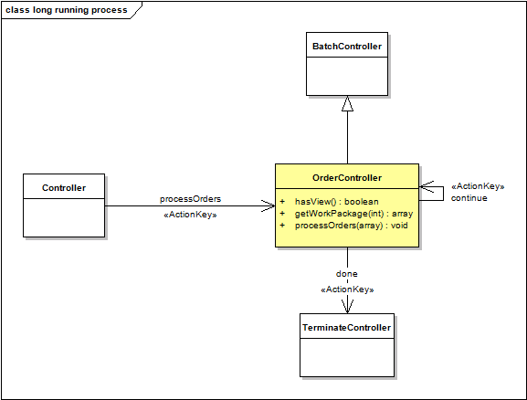Figure 4: Modeling a long running process in wCMF
require_once(BASE."wcmf/application/controller/class.BatchController.php");
/**
* @class OrderController
* @ingroup Controller
* @brief OrderController is used to process orders.
*
* <b>Input actions:</b>
* - @em processOrders Process all orders
*
* <b>Output actions:</b>
* - @em ok In any case
*
* @author ingo herwig <ingo@wemove.com>
*
* The following configuration settings are defined for this controller:
*
* [actionmapping]
* ??processOrders = OrderController
* OrderController??continue = OrderController
* OrderController??done = TerminateController
*
* [views]
*
* @author
* @version 1.0
*/
class OrderController extends BatchController
{
/**
* @see Controller::hasView()
*/
function hasView()
{
// alwas return false, because we call this controller only using ajax
return false;
}
/**
* @see BatchController::getWorkPackage()
*/
function getWorkPackage($number)
{
if ($number == 0) {
// get all order object ids and process 10 per request
$oids = PersistenceFacade::getInstance()->getOIDs('Order');
return array(
'name' => 'Process orders', // name of the package
'size' => 10, // number of oids in per request
'oids' => $oids, // all oids in this package
'callback' => 'processOrders' // the processing method
);
}
else {
// return null after the last package definition
return null;
}
}
/**
* Process the orders belonging to the given object ids
* @param oids The oids to process
*/
function processOrders($oids)
{
// we expect 10 or less object ids here
foreach ($oids as $oid) {
// process the order with the given oid
}
}
}
Note, that it's possible to define additional work packages for increasing values of the number parameter passed to the getWorkPackage method, but since we only deal with a large number of same objects in this example, it is sufficient to divide the whole amount into chunks of a fixed size (e.g. 10 orders per request). Additional information may be found in the wCMF API documentation (http://wcmf.sourceforge.net/docs/html/).
The configuration of the required actions is done in the configuration file (see chapter 4.4.4):
[classmapping]
OrderController = application/include/controller/class.OrderController.php
[actionmapping]
??processOrders = OrderController
OrderController??continue = OrderController
OrderController??done = TerminateController

Client-side
On the client side we have to create custom actions for processOrders and continue. The procedure is described in chapter 4.4.4. In this example we add the following methods to the CustomJson class:
/**
* Process all orders in the system
*
* @param successHandler A function to be called on success (optional)
* @param errorHandler A function to be called if an error occurs (optional)
*/
myApp.persistency.CustomJson.prototype.processOrders = function(
successHandler, errorHandler) {
// define the request parameters
var params = {
action: "processOrders"
}
// send the request
var transactionId = this.jsonRequest(params,
successHandler, errorHandler, this.responseHandler);
// return the transactionId that is needed to cancel the request
return transactionId;
};
/**
* Call the continue action. This is method is used by LongTask to
* to send consecutive requests to a BatchController.
*
* @param contoller The name of the controller from which this call originates
* @param successHandler A function to be called on success (optional)
* @param errorHandler A function to be called if an error occurs (optional)
*/
myApp.persistency.CustomJson.prototype.doContinue = function(controller
successHandler, errorHandler) {
// define the request parameters
var params = {
controller: controller,
action: "continue"
}
// send the request
var transactionId = this.jsonRequest(params,
successHandler, errorHandler, this.responseHandler);
// return the transactionId that is needed to cancel the request
return transactionId;
};
/**
* Default response handler, just passes the response data.
*/
myApp.persistency.CustomJson.prototype.responseHandler = function(
handler, options, data) {
// no further processing
return data;
};
Since it is not required to transform the server responses, we can use the generic responseHandler method for both requests. The doContinue method is also generic enough to be reused for different long running processes.
ChronosLib provides classes to simplify task setup and execution:
- The chi.persistency.LongTask class is used to interface server side batch processing in the client. It receives the server responses and makes the required consecutive calls. Users don't have to deal with this class.
- The chi.ui.LongTaskRunner instances are used to execute a task. The class internally uses a chi.persistency.LongTask instance to communicate with the server. The class offers many configuration options. A call to the show method starts the execution.
The following code demonstrate the usage of chi.ui.LongTaskRunner to execute the processOrders action:
// set up and run the task
var longTaskRunner = new chi.ui.LongTaskRunner({
title: chi.Dict.translate('Processing orders')+' ...',
showText: true,
autoAnimate: false,
canCancel: false,
call: function(successHandler, errorHandler) {
// do the initial call to start the process
chi.persistency.Persistency.getInstance().processOrders(
successHandler, errorHandler);
},
successHandler: function(data) {
// success close the progress window and
// display a success message
longTaskRunner.close();
alert('All orders were processed successfully.');
},
errorHandler: function(data) {
// error: close the progress window and
// display an error message
longTaskRunner.close();
alert('Order processing failed.');
},
isReturningDocument: false
}).show();

Document download
An important feature is the possibility to return a document for download at the end of the process. In the given example this could be a report that is generated while processing the orders. The following code demonstrates how this can be accomplished on the server side by adding a work package and the appropriate execution method (some code is omitted, new code is bold):
class OrderController extends BatchController
{
/**
* @see BatchController::getWorkPackage()
*/
function getWorkPackage($number)
{
if ($number == 0) {
// ...
}
elseif ($number == 1) {
// this package can be accomplished in one step
return array('name' => 'Generate report', 'size' => 1,
'oids' => array(1), 'callback' => 'getReport');
}
else {
// return null after the last package definition
return null;
}
}
/**
* Return the report to the client
* @param oids The oids to process
*/
function getReport($oids)
{
$reportFile = 'report.pdf';
// make sure that nothing is printed before and after the document output
// because this might corrupt open office files
ob_end_clean();
$this->getResponse()->setFormat(MSG_FORMAT_HTML);
header('Content-type: application/octet-stream');
header('Content-Disposition: attachment; filename="report.pdf"');
readfile($reportFile);
}
}
On the client side the document download is enabled by setting the isReturningDocument configuration property of the chi.ui.LongTaskRunner instance to true. Note, that when a document download is expected, the LongTaskRunner instance must not be closed in the success handler automatically, because this would destroy the iframe that is used to receive the document.

Internationalization
To support internationalization ChronosLib provides the class chi.Dict. This class defines a translate method which returns the localized string for a given vocabulary entry. Additionally an arbitrary list of variable values may be passed as parameters that will replace variables defined in the localized string. Variables are denoted as ${1}, ${2}, …, ${n} (see the example code below).
The localization language is selected by the user in the log-in dialog's language list box. The default value may be set in the configuration value defaultLang. Currently the list box contains de and en only.
The vocabulary is defined in the property chi.Dict.voc as a key-value list. The following code shows an example of a vocabulary, that is typically defined in a file Dict.js in the application directory:
Ext.namespace("chi.Dict");

/**
* List of all strings and translations.
*
* @type Array
*/
chi.Dict.voc = {
"ASSOCIATE_TEXT" : {
"en" : "Associate",
"de" : "Verknüpfen"
},
"DISASSOCIATE_TEXT" : {
"en" : "Disassociate",
"de" : "Verknüpfung lösen"
},
"EDIT_TEXT" : {
"en" : "Edit",
"de" : "Bearbeiten"
},
"LABEL_TEXT" : {
"en" : "Label",
"de" : "Bezeichnung"
},
"SAVE_TEXT" : {
"en" : "Save",
"de" : "Speichern"
},
"CANCEL_TEXT" : {
"en" : "Cancel",
"de" : "Abbrechen"
},
"USER_TEXT" : {
"en" : "User ${1} is logged in since ${2}",
"de" : "Benutzer ${1} ist seit ${2} angemeldet"
},
. . .
};
To retrieve a localized string in the application the following code is used:
// translate a vocabulary key to the language selected by the user
var labelText = chi.Dict.translate("LABEL_TEXT");
// result is:
// - Label if the selected language is 'en'
// - Bezeichnung if the selected language 'de'
// - LABEL_TEXT in any other case
// translate a vocabulary key with parameters
var userName = "admin";
var loginTime = "15:44";
var userText = chi.Dict.translate("USER_TEXT", userName, loginTime);
// result is:
// - User admin is logged in since 15:44 if the selected language is 'en'
// - Benutzer admin ist seit 15:44 angemeldet if the selected language 'de'
// - USER_TEXT in any other case
The translate method will return the string that was passed as parameter, if it cannot find a translation for the given language. This allows you to use strings in the default language as vocabulary keys and omit the translations in that language, which is much more convenient.

Logging
ChronosLib supports client- and server-side logging.

Client-side
The chi.Log class found in ChronosLib is used to output messages to the javascript console. Each message is assigned to a log level (one of chi.Log.DEBUG, chi.Log.INFO, chi.Log.WARN or chi.Log.ERROR). The configuration value logLevel is used to define a threshold for message output. The following example demonstrates the usage of the chi.Log class:
// log a message of level INFO
// it will be displayed if the logLevel is at least chi.Log.INFO
chi.Log.log("info text", chi.Log.INFO);

// log a message of level DEBUG
// since the message construction is a lengthy operation we test the level first
if (chi.Log.isEnabled(chi.Log.DEBUG)) {
var message = this.createSomeFancyPerformanceReport();
chi.Log.log(message, chi.Log.DEBUG);
}

// log a message of level ERROR
// it will be displayed in any case, because there is no log level above ERROR
chi.Log.error("ALERT!!!", chi.Log.ERROR);

Server-side
Log messages can be sent to the server by using the Persistency.log method. The method requires the log level (one of DEBUG, INFO, WARNING, ERROR or FATAL) in the first parameter and the message in the second. The further processing of the message depends on the server application.
// log a message of level INFO
chi.persistency.Persistency.getInstance().log("INFO", "info text");

